Title: Intelligence and Internet of Things Journal

First Author∗, Second Author, Third Author, Forth Author

Abstract
This paper presents the format of journal articles and all various parts, font types, and their size are fully characterized. Writers should note that articles which are written outside of this format are not acceptable. The abstract should give a concise and informative description of the paper and it should be written maximum in 300 words. Avoid inserting shapes and tables in the abstract.

Keywords
Maximum 8 words must be written as keywords. Keywords should include main topics of the article and be separated by “, “.

- Introduction
This document is the template for a typical journal paper. An easy way to comply with the paper formatting requirements is to use this document as a template and simply type your text into it. All papers must be written by Microsoft Word 2010 or the next versions. To write the article, the authors should pay attention to the following points:
- Your paper must be in A4 size with two columns format.
- The article (except abstract and keywords) should be written in two columns with 7.46 cm width and 1 cm spacing between with a single line.
- The margins must be set 3 cm for top and bottom and 2.5 cm for left and right.
- The length of your paper should be between 7 to 10 pages.
- All manuscripts must be in English with the fonts listed in the table1.
Table 1. An example of a table
Subject | Font | Size
Title | Times New Roman Bold | 16
Authors | Times New Roman | 12
Sections title | Times New Roman Bold | 14
Sections subtitles | Times New Roman Bold | 12
Abstract, keywords and main text | Times New Roman | 12
Footnotes and references | Times New Roman | 10
Title of Tables and Figures | Times New Roman Bold | 10
Text of Tables | Times New Roman | 10

- Article Sections
The article should be included abstract, keywords, introduction, main text, conclusion and references. All sections should be numbered with numerals.
- Main Text
Once you have provided background material and stated the problem or question for your study, tell the reader the purpose of your study. Usually the reason is to fill a gap in the knowledge or to answer a previously unanswered question.
This section provides the reader with all the details of how you conducted your study. You should mention the following details:
  - Theoretical Foundations of Research
  - Research Background
  - Research Hypotheses
  - Research Methods
  - Results
  - Discussion and Conclusions
  - References
- Tables and Figures
All of the Tables and Figures must be in the center of the page. Tables and figures should be cited consecutively in the text. Title of the Tables must be in the top corner of the Table and the title of Figures must be in below of them at center. All tables and figures should have title and be numbered.
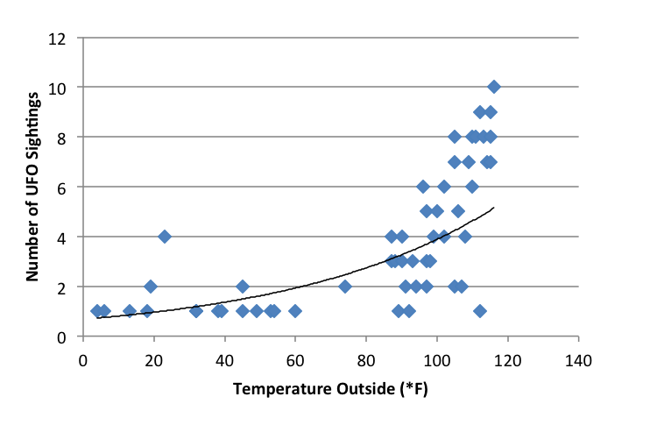
Figure1. An example of a figure
- Equations
Equation must be written in 10-point Times New Roman with numbering (Using Microsoft Equation recommends). For example:
(1)
- References
Every statement of fact or description of previous findings requires a supporting reference. To refer to a reference, just insert the reference number inside a [] at the end of the sentence. For example [2] [5].
- Appendix
Add your appendix immediately following your reference pages and label it as Appendix A, B, C, etc. Use these labels when discussing the appendix in the body of your paper. Appendix should be included information that is too detailed for the text of the paper itself.

∗ Corresponding author
Academic Rank, Member of Working Groups, Organization and etc., Email
Academic Rank, Member of Working Groups, Organization and etc., Email
Academic Rank, Member of Working Groups, Organization and etc., Email
Academic Rank, Member of Working Groups, Organization and etc., Email

